1. **Install Terraform on your PC**

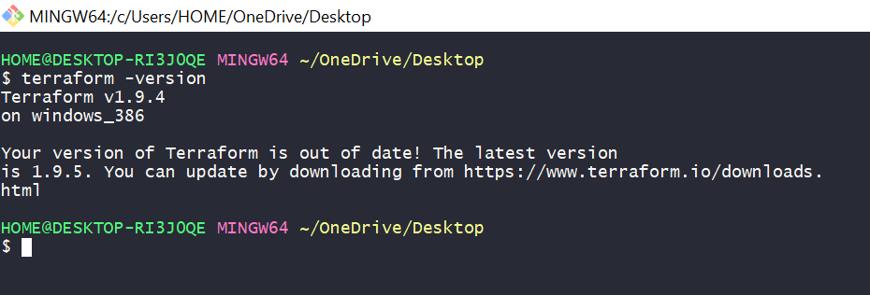

1. **Execute all the templates shown in video.**

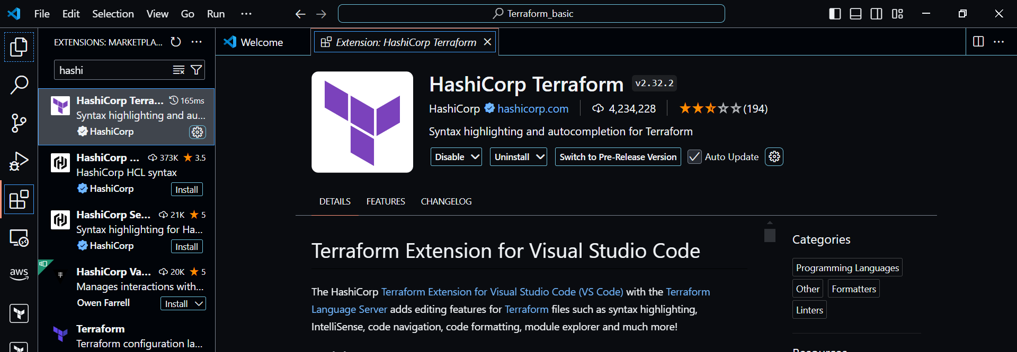

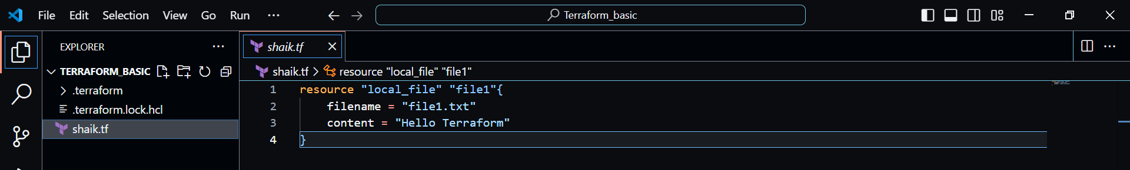

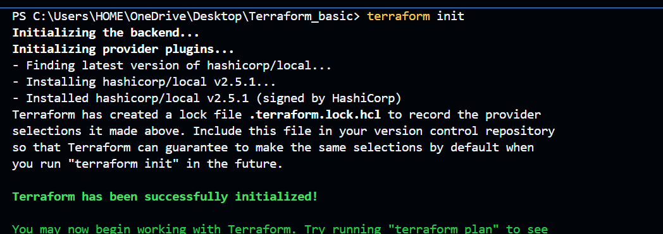

**Terraform plan**

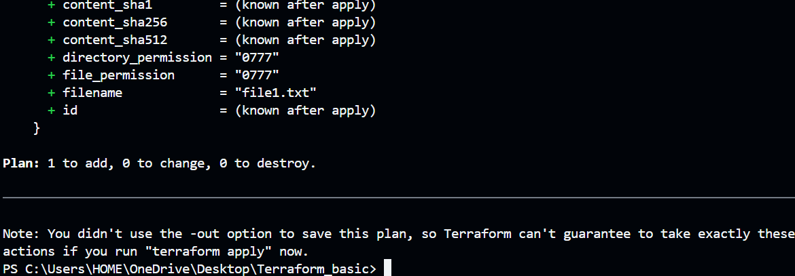

**Enter value yes**

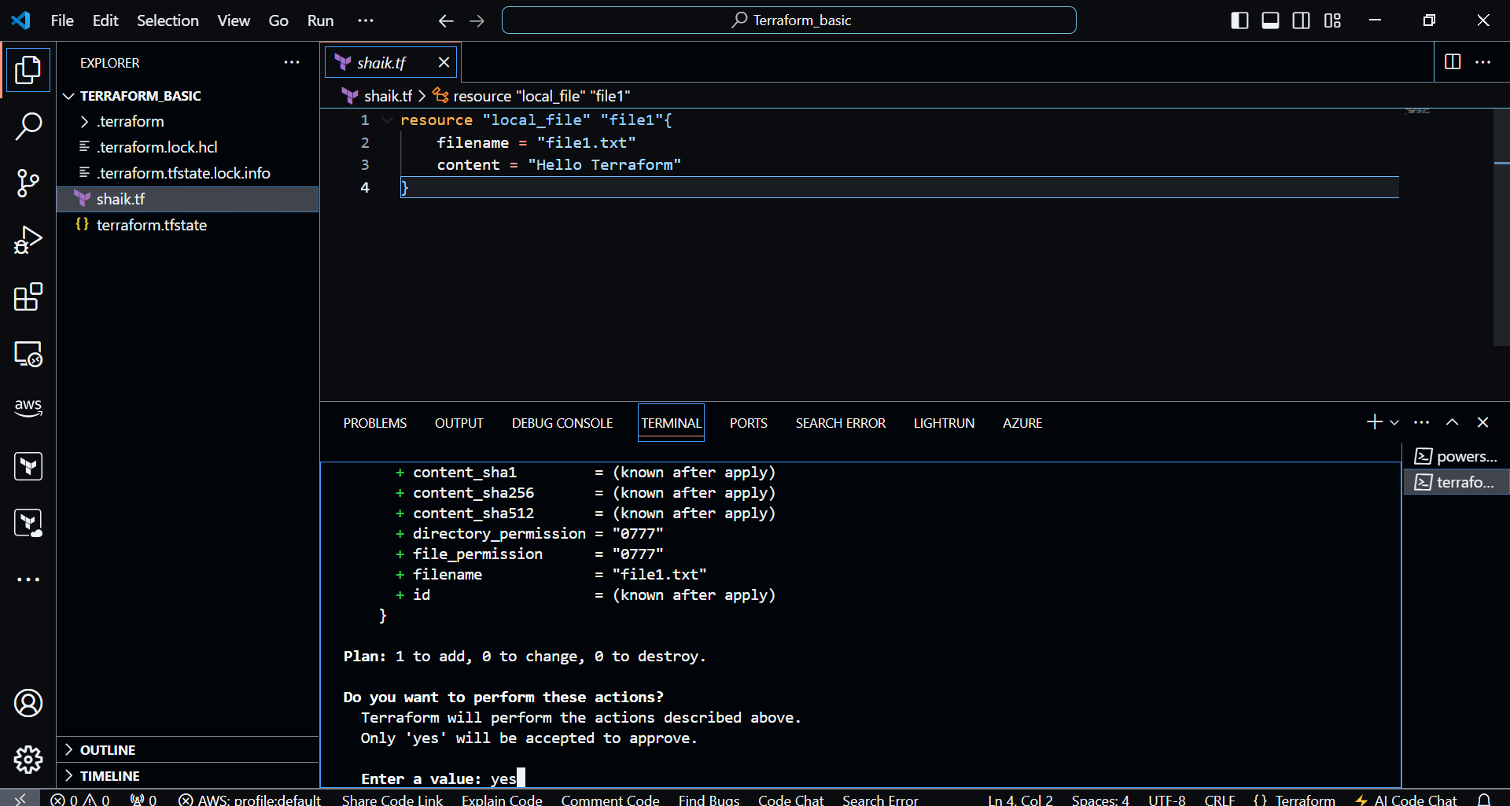

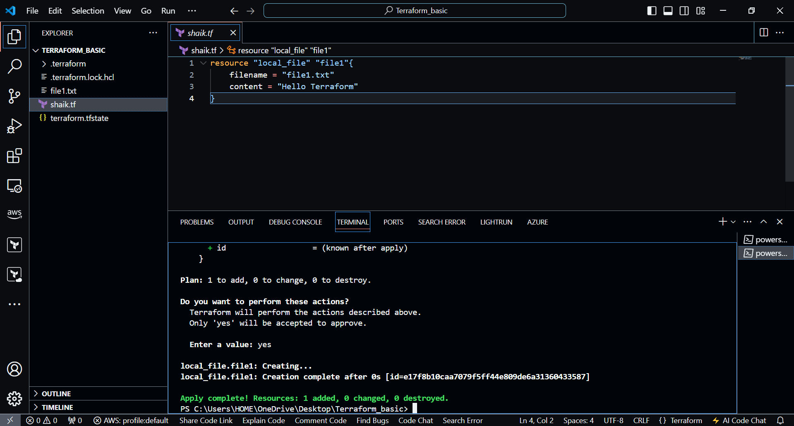

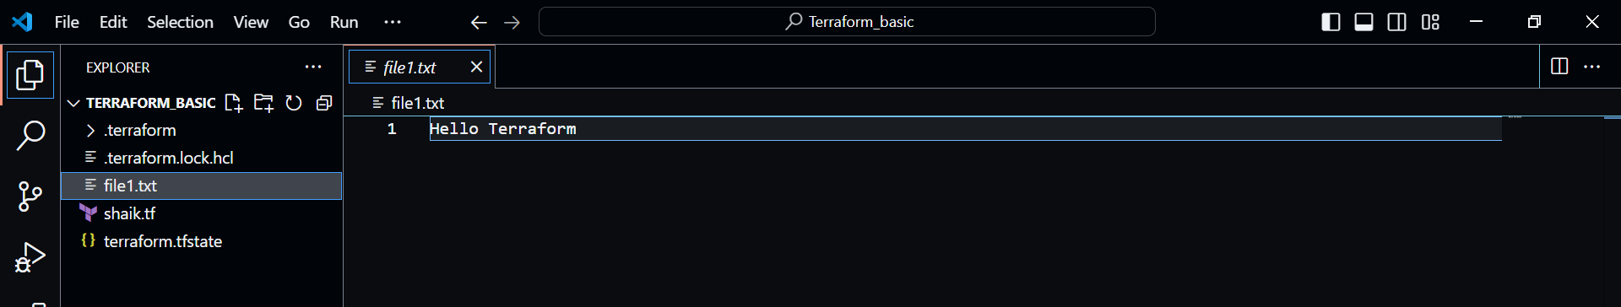

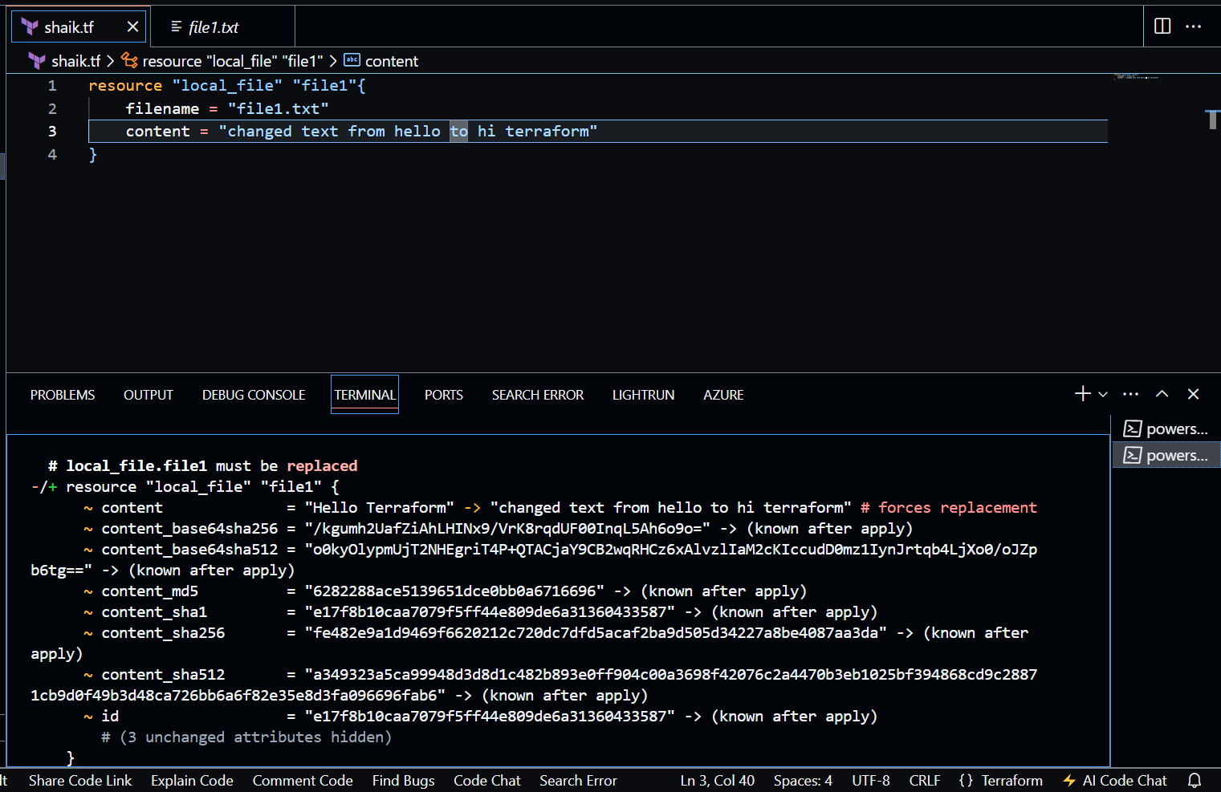

**Change text >> save >> terraform plan**

**Terraform apply >> yes**

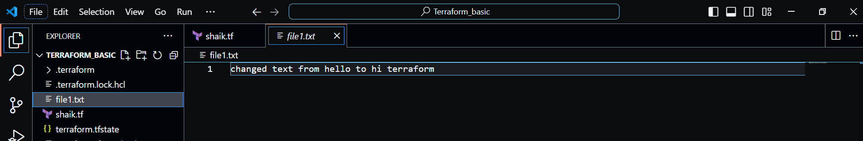

**Terraform provider**

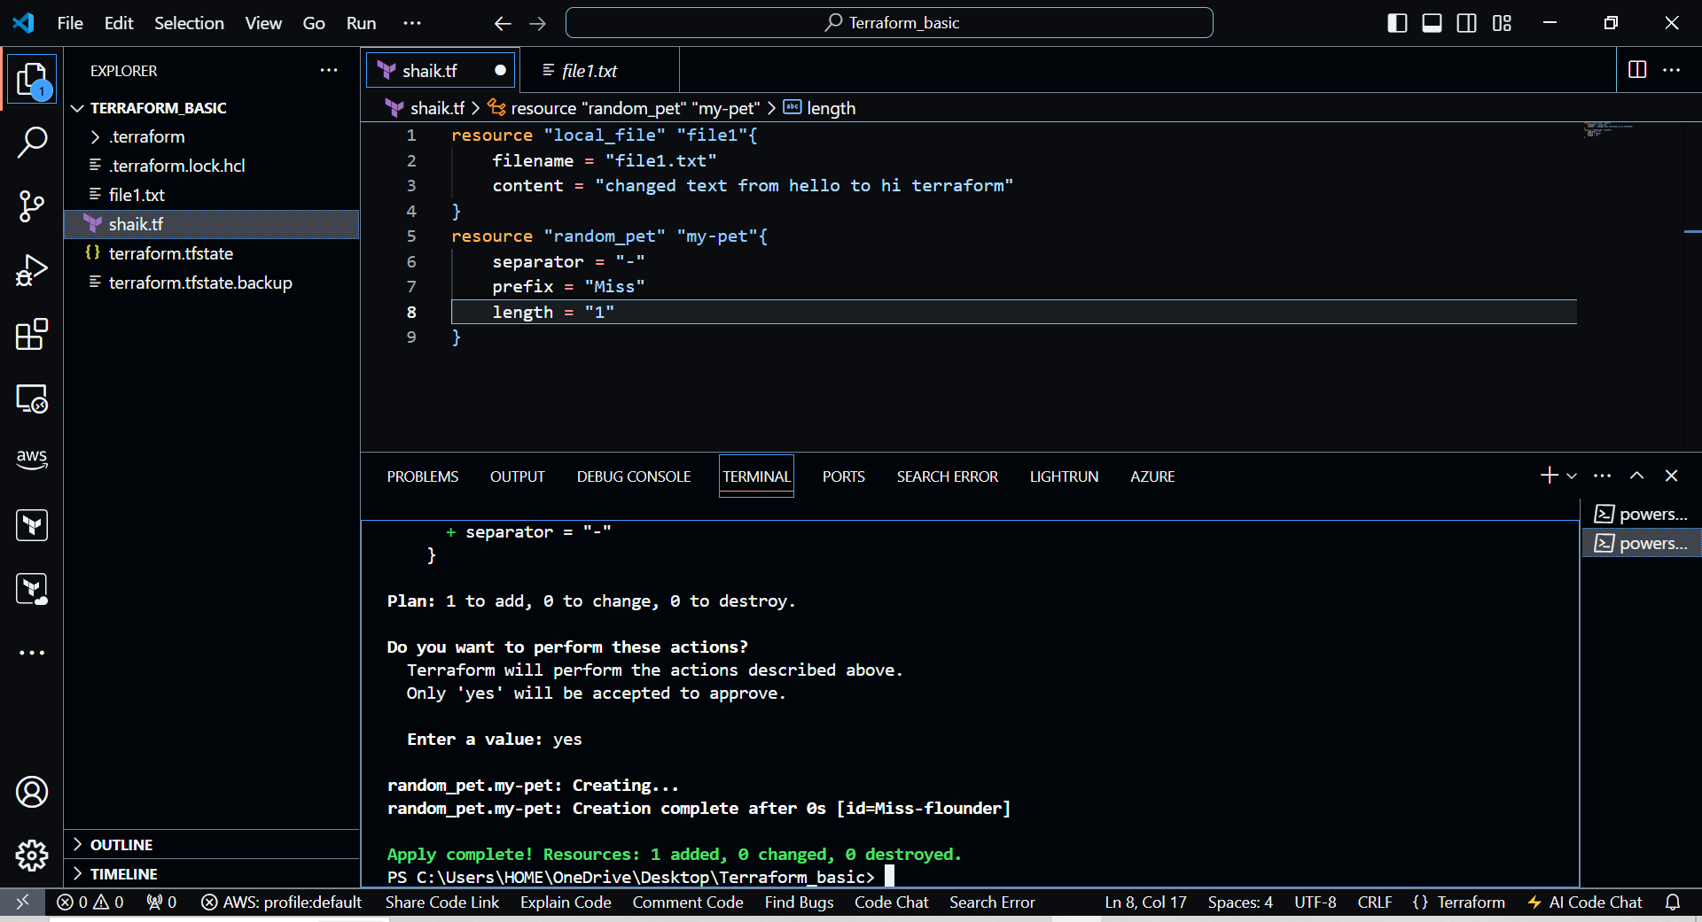

1. Integrate a sample Terraform template in jenkins.



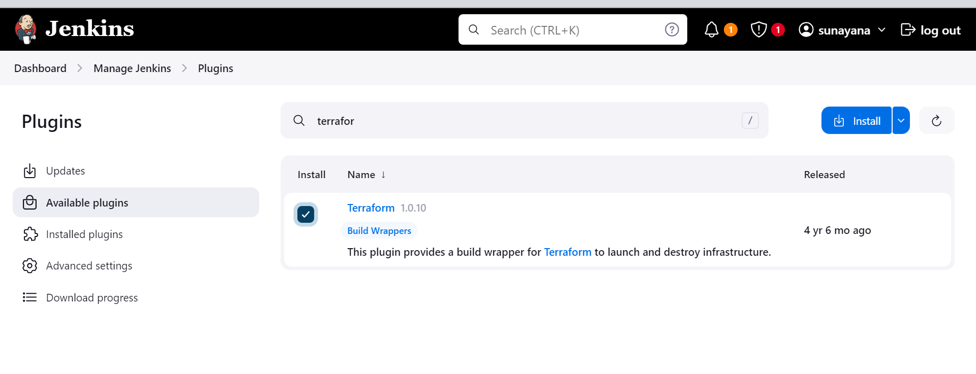

**sudo yum install -y yum-utils shadow-utils**

**sudo yum-config-manager --add-repo https://rpm.releases.hashicorp.com/AmazonLinux/hashicorp.repo**

**sudo yum -y install terraform**

